To All Our HTA Families;

We need everyone's co-operation in ensuring that our students are safe arriving to and dismissing from school.
Please note the following areas are NO PARKING ZONES.

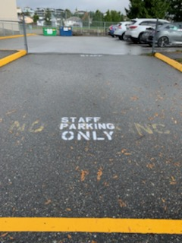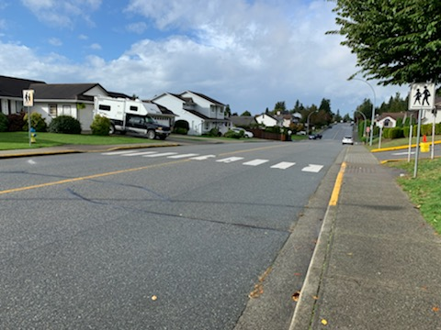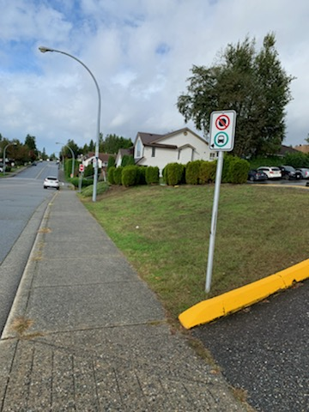

Please be respectful of the Public Transit Stop and the Staff Parking Lot .

Please ensure you are not blocking drivers' view of students and families using the crosswalk.

Thank you for your assistance and co-operation in keeping our students safe.

Linda Hamel
Principal
Hillside Traditional Academy
604 826-4187

I acknowledge that I work and learn on the Traditional, Ancestral, Unceded, and Shared territories of the Stó:lō people, the Matheqwí, Sq’éwlets, Qwó:ltl’el, and Leq’á:mel First Nations.

