Hello HTA Families,

The eagerly awaited student masks have arrived from the Ministry of Education🙂

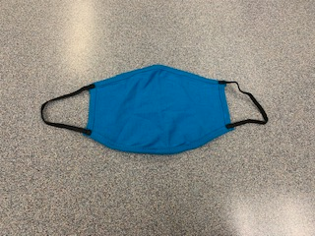

At this time, we will be issuing one mask per student. Teachers will be labelling each mask with student names. Beginning Monday, October 19th, student masks MUST follow the school colours of solid blue, black, or white and be one solid colour (no patterns). If a student arrives with a mask that does not meet these criteria, they will be issued a mask from the Ministry of Education. The other mask will need to return home and students will use the one provided.

Please remember that at this time, students are not mandated to wear a mask.

Linda Hamel
Principal
Hillside Traditional Academy
604 826-4187

I acknowledge that I work and learn on the Traditional, Ancestral, Unceded, and Shared territories of the Stó:lō people, the Matheqwí, Sq’éwlets, Qwó:ltl’el, and Leq’á:mel First Nations.

